SECTION 14 – ATTACHMENTS

Presented in this Section are

- Applicable forms, instructions, reports and worksheets referenced in the Manual and organized by the responsible agency

- Facility Program Manual, Current Edition, produced jointly by Maryland Department of Budget and Management and Maryland Department of General Services

- Procedure Manual for Professional Services, Current Edition, produced by Maryland Department of General Services

- Instructions for the Preparation and Submission of Non-State Projects within a State Grant and Loan Program, Current Edition, produced by Maryland Department of Budget and Management

- Roofing Policy, produced by Maryland Department of General Services

  - DEPARTMENT OF BUDGET AND MANAGEMENT FORMS

- CBIS Part IIIA Report: Project Detail [See 14.06 Instructions for the Preparation and Submission of Non-State Capital Project Requests within a State Grant and Loan Program]
- CBIS Cost Estimate Worksheet [See 14.06 Instructions for the Preparation and Submission of Non-State Capital Project Requests within a State Grant and Loan Program]
- CB Form B: Five-Year Capital Improvement Program, Summary of Agency Project Requests
- CB Form G: Equipment and Furnishings Request

Environmental Assessment Form (EAF) [See 14.04 Facility Program Manual]
- Project Consistency Report (MDP Form) [See also 14.04 Facility Program Manual]
- Project Review Checklist (For agency use only)
CBIS Part IIIA Report: Project Detail

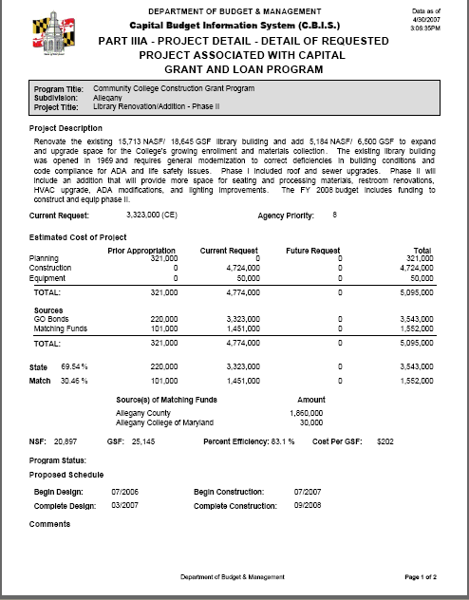

CBIS Cost Estimate Worksheet (CEW)

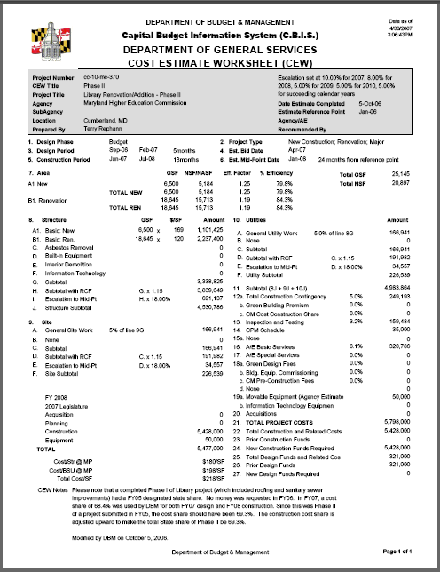

INSTRUCTIONS - CB Form B: Summary of Agency Project Requests
CB Form B is a summary sheet. All projects requested by an institution or agency for the next capital budget and those proposed for the four subsequent fiscal years shall be summarized on this form. This summary constitutes a continuing five year capital improvements program as requested by the institution or agency.

Each year the five-year capital improvement program must be updated to take into account
- Any project previously requested for the capital budget for which an appropriation was not provided
- Necessary revisions in the cost and/or timing of previously requested projects as may be dictated by changed conditions
- Additional project needs
Item | Instructions for Completing Item
1-2 | Match college information entered on CB Form A.
3a-b | Self explanatory
4 | All projects proposed by an agency or by an institution to be partially or wholly funded during the next five fiscal years shall be listed in this column, in order of priority, starting with the projects requested for the next capital budget and followed by those proposed during the four subsequent fiscal years. Space is provided for three projects per page. Enter the priority number for each project in the narrow column at the left margin of Form B. Indicate for each project, on the lines provided, the cost for property acquisition, planning, construction (including utilities and site improvements), and capital equipment, inclusive of all fund sources. Total those costs on the line provided.
5 | Show any non-State funds available or anticipated for the project listed in item 4, such as federal aid, revenue bond proceeds, or institutional funds. Show separately the amounts of non-State funds available for property acquisition, planning, construction, and capital equipment.
6 | Indicate any prior appropriations of State funds for the project listed in item 4. List separately the appropriations for property acquisition, planning, construction, and capital equipment.
7-8 | Enter the amounts required for the project listed in item 4 in the appropriate column(s) for the fiscal year(s) that an appropriation is desired. Show separately the amounts required for property acquisition, planning, construction, and capital equipment in each year. The total of the amounts shown in items 5, 6, 7 and 8 should equal the total in column 4 unless additional funds will be requested beyond the five-year time frame of CB Form B.
9 | On the last page of the listing, total the amounts of State capital funds to be requested for each fiscal year.
Note | A college with sub-units should submit a separate CB Form B for each sub-unit listing all projects proposed by the department for the sub-unit in order of priority assigned by the department.  CB Form B is on the following page.

CB Form B
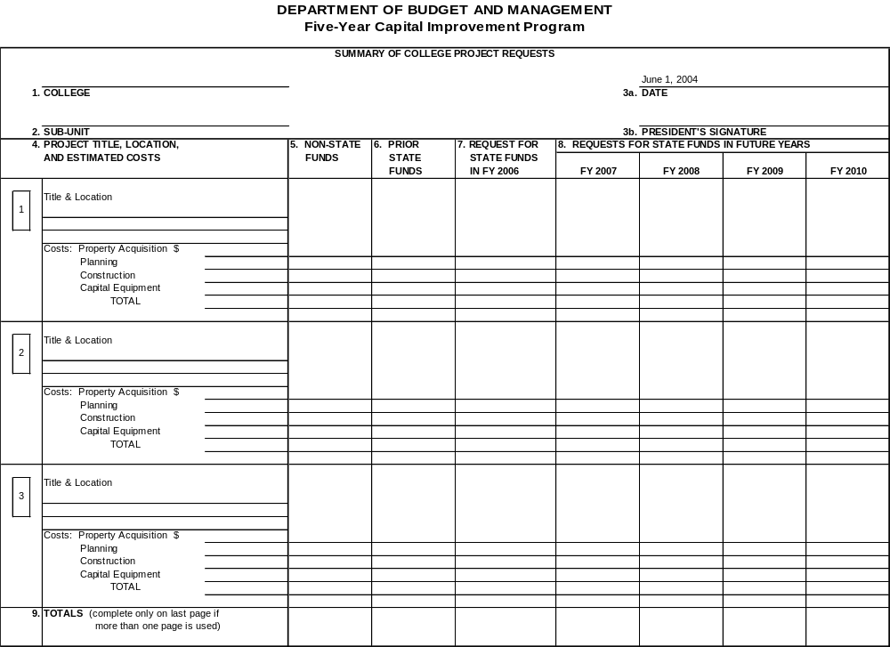

INSTRUCTIONS - CB Form G: Equipment and Furnishings Request
This form is used to list all items of equipment and furnishings, which are needed to make a project operational, regardless of projected fund source. The form contains space to report 25 items per page.

An electronic copy of this form should be submitted to the Department of Budget and Management by June 30th of the year in which the agency will submit a request for equipment funding for the project (e.g., June 30, 2007 for a FY 2009 request).

On each page, at the top, complete the lines for agency, (name of) project, and fiscal year. The fiscal year is the year in which capital equipment funds will be requested.

On each item line, list an item along with a suggested manufacturer and product number, if available. Remember that State law specifies that State Use Industries products must be acquired if available even if at a greater cost than available from a private vendor. For items which vary in size, include dimensions if available. Complete the columns for quantity, net unit cost, and total cost. Note that total cost equals quantity times net unit cost. Round all costs to the nearest dollar.

At the bottom of the page, indicate the number of that page and the total number pages.

Do not complete the item approval number column or any of the other approved columns.

Note CB Form G is on the following page.

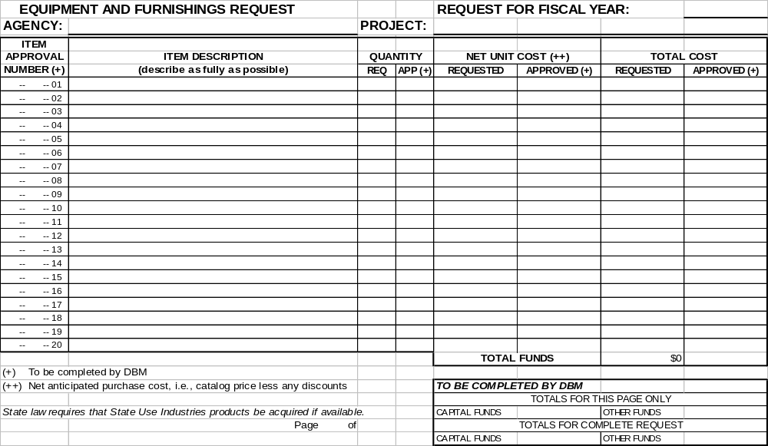CB Form G
PROJECT CONSISTENCY REPORT
(File with Maryland Department of Planning)

This review is undertaken by the State of Maryland pursuant to §5-7A-02 of the State Finance and Procurement Article. Projects or actions are evaluated for consistency with the State’s Economic Growth, Resource Protection, and Planning Policy in accord with Executive Order 01.01.1992.27.

Project Title ____________________________________________________________

Project Location ________________________________________________________

Project Description ______________________________________________________

______________________________________________________________________

Approximate Funding Share
LOCAL | STATE | FEDERAL | OTHER

Determination □ Consistent

□ Inconsistent with extraordinary circumstances

Brief description of extraordinary circumstances:

_______________________________________________

_______________________________________________

Sponsor Agency: ___________________________________ Date: _____________________

Sponsor Agency Contact: _____________________________ Phone: ___________________

Return to: State Clearinghouse
Maryland Department of Planning
301 West Preston Street
Baltimore MD 21201-2365
410-767-4490; FAX 410-767-4480
PROJECT REVIEW CHECKLIST
(For agency internal use only. Record determination on Project Consistency Report.)

Project Title __________________________________________________________________________

Project Location ______________________________________________________________________
(County and nearest Major intersection)

Project Description ____________________________________________________________________

___________________________________________________________________

Approximate Funding Share
LOCAL | STATE | FEDERAL | OTHER

TIER I
Y N
□ □ 1. Does the project add capacity to an existing facility or provide new capacity for an area not
currently served by the facility?
□ □ 2. Does the project facilitate changes in the existing pattern of growth?

If answer to either question is “yes,” proceed to Tier 2.

TIER 2
□ □ 1. Is the project consistent with the local comprehensive plan?
□ □ 2. Does the project support development in a suitable area, a designated development area, or a redevelopment area?
□ □ 3. Can the project be designed to prevent adverse impacts to sensitive areas?
□ □ 4. If in a rural area, does the project promote compact growth in existing population centers?
□ □ 5. Does the project provide opportunities to conserve resources?
□ □ 6. Does the project promote economic growth and development in accord with the other elements of the State’s Growth Policy?

Explain “no” answer on reverse. If determination is that the project is “inconsistent,” proceed to Tier 3.
TIER 3
□ □ 1. Do extraordinary circumstances exist which make the project or action necessary to construct despite a finding of inconsistency in Tier 2? If so, document.
□ □ 2. Is there no reasonably feasible alternative to the project? If so, document.

Determination: □ Consistent □ Inconsistent with extraordinary circumstances

Sponsor Agency Contact: __________________________________ Phone: ________________

3/12/03

14.02 DEPARTMENT OF GENERAL SERVICES FORMS/INSTRUCTIONS

- Building Code Study Data [See 14.05 Procedure Manual for Professional Services]
- Building Efficiency Factors [See 14.04 Facility Program Manual]

CB Form F: Net Effect on Agency’s Operating Budget [See 14.04 Facility Program Manual]
- CC Form M: Letter of Intent [See 14.03 MHEC Forms]
- Certificate of Project Expenditures (CPE)
- DGS Board of Public Works (BPW) Agenda Item Request A/E Contract Award
- DGS Board of Public Works Agenda Item Request Construction Award
- DGS Board of Public Works Agenda Item Request Furniture and Equipment Award
- DGS Community College Project Closeout
- DGS Cost Estimate Worksheet (CEW) [See 14.05 Procedure Manual for Professional Services]
- DGS Standard Form of Agreement with Architects and Engineers [See 14.05 Procedure Manual for Professional Services]
- DGS Warranty Inspection Report [See 14.05 Procedure Manual for Professional Services]
- Drawing Sheet Format [See 14.05 Procedure Manual for Professional Services]
- Environmental Assessment Form (EAF) [See 14.04 Facility Program Manual]
- General Services Administration (GSA) Standard Form (SF) 254 [http://contacts.gsa.gov/webforms.nsf/0/CA616E6C247033EA85256A1F005D3519/$file/Sf254.pdf]
- GSA SF 255 [http://contacts.gsa.gov/webforms.nsf/0/ECFA4FE8C937A2F185256A1F005D5EEC/$file/sf255.pdf]
- Monthly Progress Report [See 14.05 Procedure Manual for Professional Services]
- New Building Project Checklist [See 14.04 Facility Program Manual]]
- Office Space Standards [See 14.04 Facility Program Manual]
- Project Consistency Report [See 14.04 Facility Program Manual]
- Project Description Sheet [See 14.05 Procedure Manual for Professional Services]
- Renovation Project Checklist [See 14.04 Facility Program Manual]
- Request for Determination of Prevailing Wage Rates (Department of Labor, Licensing and Regulation) [See 14.05 Procedure Manual for Professional Services]
- Review Drawing Distribution [See 14.05 Procedure Manual for Professional Services]
- Sample Cover Sheet [See 14.05 Procedure Manual for Professional Services]
- Sample Project Manual Cover [See 14.05 Procedure Manual for Professional Services]
- Site Development Project Checklist [See 14.04 Facility Program Manual]
- Standard Estimating Format [See 14.05 Procedure Manual for Professional Services]
- Summary – Areas, Volume & Efficiency (AVE) [See 14.05 Procedure Manual for Professional Services for related forms]
- Tabulation of Gross Area [See 14.05 Procedure Manual for Professional Services]
- Utility Project Checklist [See 14.04 Facility Program Manual]

INSTRUCTIONS – Certificate of Project Expenditures
The first section is self explanatory.
Item | Instructions for Completing Item
1 | Enter the total amount of the contract approved by the Board of Public Works to date. (This amount should include the base contract only. Contingency and CITS amounts should only be added on the final CPE at closeout.)
2 | Enter the total local share of contract approved by the Board of Public Works and included on the appropriate BPW agenda item. (This amount should include the base contract only. Contingency and CITS amounts should only be added on the final CPE at closeout.)
3 | Enter the sum of all payments made by the college or the local subdivision, as applicable. (Do not include change orders in this amount until the final CPE at closeout.)
4 | Item 3 minus Item 2. Should the payee be the vendor, there should be no overpayment and this amount should be zero.
5 | Enter the total State share of contracts approved by the Board of Public Works and included on the appropriate BPW agenda item. (This amount should include the base contract only. Contingency and CITS amounts should only be added on the final CPE at closeout.)
6 | The amount is equal to the eligible costs invoiced to date, minus the local share paid to date (Item 3.)
7 | Self explanatory.
8 | (Item 6 minus Item 7)
Certification. Complete remainder of form, lining out the wording not applicable on the certification portion, i. e., design, construction, furniture/equipment, and telecommunications. An authorized member of the board of trustees must sign the Certificate of Project Expenditures upon completion and submit the original and two copies of the form, canceled checks and invoices to Department of General Services.

Note. The CPE form is on the following page.

CERTIFICATE OF PROJECT EXPENDITURES
MARYLAND COMMUNITY COLLEGES

Date Submitted: |  | College:

MHEC Project No.: |  | Project Title:

Date Approved by BPW: |  | CPE Sequential No. & Phase:

Maryland Consolidated Capital Bond Loan of |  | (Calendar Year)

Name of Payee: |  | Federal I.D. No.:

Address of Payee:

1. Total cost of contract approved by the Board of Public Works to date
2. Total Local Share of contract approved by the Board of Public Works to date
3. Total Local Share Paid to date of approved contract
4. Overpayment of Local Share (Line 3 minus Line 2)
5. Total State Share of Contract approved by Board of Public Works
6. Amount of grant eligible for payment to date
7. Less amount of prior State payments to date
8. Amount requested for current payment

I further certify that the Local Share as indicated on line 3 above has been paid. I further certify that (design) (construction) has progressed as indicated on the attached (architect’s) (contractor’s) requisition for (partial) (full) payment.

Recommend Approval and Certify correctness: |  | Board of Trustees Authorized Signature:
Chief Facilities Officer Date
 |  | Secretary-Treasurer
 |  | Title Date

Approved for Payment: |  | Date:

Submit original + two (2) copies

BOARD OF PUBLIC WORKS

AGENDA ITEM REQUEST

A/E CONTRACT AWARD

Community College: |  | State Project No.:
Project Title:
Project Scope:
Advertisements
(When & Where)
No. firms responding |  | #Firms Mailed Direct
A/E Firm & Address
Procurement Method | Competitive sealed proposals MD Arch/Engr Services Act Competitive Bids
A/E Fed. I.D. No. |  | Tax Verification #
A/E Fee Negotiated |  | Construction Cost Est.

 | CHECKLIST - REQUIRED BPW BACKUP INFORMATION
 | Letter to MHEC requesting BPW item preparation by DGS
 | Copy of advertisement for RFP
 | List of firms mailed direct (name/address)
 | List of firms responding to advertisement (name/address)
 | Copy of A/E agreement & fee breakdown (basic & special services)
 | Copy of signed Petitions and Resolutions
 | Description of A/E selection process including ranking criteria and point values
 | Scoring Table listing ranking of firms in descending order
 | Support for soliciting MD firms if selected A/E is out-of-state
 | Estimated project design & construction schedule
 | Latest campus map

**Requests for BPW Items should be sent to DGS, DBM and MHEC

PROVIDE REQUESTED INFORMATION ON FORM - DO NOT SUBSTITUTE ”SEE ATTACHMENT”

BOARD OF PUBLIC WORKS

AGENDA ITEM REQUEST

CONSTRUCTION AWARD

Community College: |  | State Project No.:
Project Title:
Project Scope:
Number of bidders |  | #Firms Mailed Direct
Contractor & Address
Contractor Fed. I.D. No. |  | Tax Verification #
Contract Amount |  | Perform Bond Required

 | CHECKLIST - REQUIRED BPW BACKUP INFORMATION
 | Letter to MHEC requesting BPW item preparation by DGS (include base bid & alternates accepted)
 | Copy of bid advertisement
 | Description of all alternates
 | List of firms mailed direct (name/address)
 | Letter of recommendation for award from design consultant
 | List of bidders (name/address)
 | Bid proposal of low bidder (Sole source requires written justification from Board of Trustees)
 | Copy of signed Petitions and Resolutions
 | Bid tabulation sheet sorted from lowest to highest bidder (include alternates if applicable
 | Copy of contractors current business license for operating in MD
 | Copy of performance bond
 | Support for soliciting bids if only one bidder and explanation why single bid received
 | Support for soliciting MD firms if selected contractor is out-of-state
 | Estimated construction schedule
 | Latest campus map

BOARD OF PUBLIC WORKS
AGENDA ITEM REQUEST
FURNITURE AND EQUIPMENT AWARD

Community College: |  | State Project No.:
Project Title:
Scope :
Brief description of work and/or equipment being provided by each vendor (use separate form for each vendor)
Advertisements
(When & Where)
No. firms responding |  | #Firms Mailed Direct
A/E Firm & Address
Procurement Method | Sole Source Act Competitive Bids  InterGov Contract
VendorFed. I.D. No. |  | Tax Verification #
Contract Amount |  | Estimated cost

 | CHECKLIST - REQUIRED BPW BACKUP INFORMATION
 | Letter to MHEC requesting BPW item preparation by DGS
 | Copy of advertisement
 | List of firms mailed direct (name/address)
 | List of firms responding to advertisement (name/address)
 | Copy of signed Petitions and Resolutions
 | Support for soliciting MD firms if selected A/E is out-of-state
 | Estimated project design & construction schedule
 | Latest campus map

**Requests for BPW Items should be sent to DGS, DBM and MHEC


COMMUNITY COLLEGE
PROJECT CLOSEOUT

College |  |  |  |  | Date
Project Title |  |  |  |  | State Project No.
PROJECT FUNDING SUMMARY
Phase | BPW Date | Total BPW Allowance | Local Share | State Share | State Share Paid | State Share Remaining
Design
Construction
CITS
Contingency
F & E
Other | N/A
TOTALS
SUMMARY OF ADDITIONAL COSTS
Additional Costs |  | Total Cost | Amount Eligible | Local Share | State Share
Addt'l A/E fees
Change Orders
CITS
Reimbursables
Other
TOTALS
TOTAL REMAINING STATE FUNDS
TOTAL STATE SHARE OF ELIGIBLE CLOSEOUT COSTS
FINAL STATE CLOSEOUT CPE AMOUNT
REVERSION

INSTRUCTIONS – DGS Cost Estimate Worksheet (CEW)
The Cost Estimate Worksheet (CEW) is used to support the funding requested for a project in the Capital Budget.

Complete the general information at the top of the worksheet. Insert the Name of the file (if applicable), Escalation % (construction cost estimates should be escalated to the midpoint of construction to account for the effects of inflation), Project Title, Project Number (Use the DGS Project Number - if assigned), Location (include County), Institution (for example: UMS, MSU, DPSCS, DHMH, etc.), Estimate Preparation Date, Prepared by, Estimate Reference Point (see note below) and Agency/AE.

Note: The Estimate Reference Point is the time frame on which the costs used to prepare the estimate are based. For example, if RSMeans Construction Cost Data 2007 was used to estimate the costs of the project, the estimate reference point would be January, 2007. Check the estimating guide or the A/E’s estimate being used to determine the reference point by which the costs are established. If prices which are quoted by supplier are used to establish the costs of the project, the estimate reference point should be taken as the date at which the supplier’s quote is no longer valid.

Contact Joseph Pitruzzella at (410) 767-4397 in the DGS Cost Center for assistance in preparing or submitting the CEW.
Item | Instructions for Completing Item
1 | Indicate the design phase of the project. Check the applicable block.
2 | Indicate the type of project. Check the applicable block(s).
3 | Indicate design period in month/year from start to completion and the total number of months, e.g., Jan-03 Dec-03 12.
4 | Indicate construction period in month/year from start to completion and the total number of months, e.g., Jan-04 Jun-05 18.
5 | Provide a brief project description. Note any special features of the project, problems which may be encountered, and any assumptions made in order to prepare the CEW.
6 | Estimate the bid date of the project.
7 | Based on the established project schedule, estimate the mid-point of the construction period. Allow time from project bid date to construction start date to account for award of the project and time before the contractor receives notice to proceed with construction. Enter the number of months from the estimate reference point to the mid-point of construction.
8 | List the gross square footage for each floor of the building under the appropriate column. These figures are used to determine the structure costs for Items 9A and 9B. Also, list the total net square footage (NSF) and the total gross square footage (GSF). Gross Areas are to be calculated in accordance with instructions in the DGS Procedure Manual for Professional Services. Show the Efficiency Factor (GSF/NSF) and Percent Efficiency (NSF/GSF x 100). For projects being requested in FYs 2010 – 2013, the cost estimate should use the minimum efficiency factor when calculating the net to gross square foot ratio.

9* | List the project costs in the appropriate spaces. In establishing the costs for Item 9, include costs for the project’s General Conditions and costs for the General Contractor’s overhead and profit. Do not include any escalation costs in the base costs of the project.
10* | Use Items A through F to describe the site work items that are relevant to the project and list the estimated costs for those items. Below are listed typical items to include: site preparation (grading, compaction), dewatering, retaining walls, shoring & underpinning, excavation support systems, slope/erosion control, paving-curbing, surfacing, lighting, landscaping, marine work, fencing, drainage, building demolition.
11* | Use Items A through F to describe the utility items that are relevant to the project and list the estimated costs for those items. Below are listed typical items to include: water treatment plant, wastewater treatment plant, components, septic systems, water distribution-domestic, water distribution-fire, well, sanitary distribution, steam distribution, electric distribution, telecommunications, emergency power, utility tunnel, fuel systems.
* | Generally, budget estimates are prepared using 10% for general conditions and 15% for the general contractor's overhead and profit. In addition, a market variance may need to be applied to account for market conditions at bid time. Estimators (design) contingency may range up to 25% depending on the detail of the project information. The above factors are generally used by DGS to adjust the basic cost as established, using Means as an estimating guide. For new building construction, Items 10 and 11 portray the costs for all site work and the utility improvements in the project which are over 10 feet from the structure.  On Item 9F, include the estimated cost for information technology systems and equipment for that portion of the system installed as part of the general construction contract. Items may include common equipment such as electronic private branch exchange (PBX), fiber optic or copper vertical riser distribution cables, cable termination equipment and related wiring closets on each floor, and wire connecting the wire closet terminations to the wall jacks or other outlets to which telephone stations and computers will be connected.  On Items 9H, 10H, and 11H, list the regional construction factor for the county that the project is located in. The regional construction factor accounts for variations in the wage rates established by the Department of Labor, Licensing and Regulation (DLLR) as applicable to the 24 localities of Maryland. Refer to the DLLR web site for further information http://www.dllr.state.md.us/. The factors for all budget types of estimates are listed below:  For all A/E submissions, the regional construction factor is 1.0, since only applicable regional costs, based on wage and market evaluations, should be included in design estimates.  On Items 9J, 10J, and 11J determine the amount of escalation to be added to the basic project cost. Escalation is taken from the estimate reference point, established under the general items at the top of the CEW form, to the estimated mid-point of construction, established in Item 7. This time frame is multiplied by an annual escalation rate to determine the percent of escalation to be used. The amount to be inserted on Item J is equal to line I multiplied by the percent of escalation. On Item K add the subtotal of Item I with the escalation cost of Item J. The total of Items 9K, 10K, and 11K is the expected construction cost at bid.  The escalation factor used for budget estimates is updated annually and provided by the Department of Budget and Management as part of the Instructions for the Preparation and Submission of Capital Project Requests. The escalation factor used for design estimates should be based on market conditions and industry forecasts projected at the time the design occurs.
  Factor | County
  1.00 | Anne Arundel, Baltimore City, Baltimore, Carroll, Harford, Howard, Montgomery, Prince George's
  1.25 | Calvert, Charles, St. Mary's
  1.15 | Allegany, Frederick, Garrett, Washington
  1.25 | Caroline, Cecil, Dorchester, Kent, Queen Anne's, Somerset, Talbot, Wicomico, Worcester
12 | Sum the amounts listed for Items 9K, 10K, and 11K. This amount constitutes the estimated construction cost as of the mid-point of construction date.
13a | A green building construction premium should be computed as approximately 2.5% to 3% of Item 12. This premium is for the application of costs related to the construction of a building associated with green construction practices, in conformance with the LEED Green Building Rating System™ version Silver as outlined by the Maryland Green Building Network (GBN.) This factor can be increased or decreased, based on the specific information and/or applications identified by the cost estimate preparer.
13b | A contingency amount is computed as 5% of Item 12. This contingency is considered a construction contingency for change orders (CO) during construction. For projects being requested in FYs 2010 – 2013, use a 10% contingency instead of the current 5%. When your project reaches the current year request, the 10% contingency should be reduced to 5%. That 5% should be incorporated into the base cost of the structure in Item 9.
14 | Insert an amount for Construction Inspection and Testing Services (CITS.) Depicted below are rates applied against the sum of Items 12, 13a, and 13b:
  Rate | Expected Construction Cost
  4.6% (0.046) | Up to $4,000,000
  3.2% (0.032) | $4,000,000 - $9,000,000
  2.2% (0.022) | Greater than $9,000.000
15 | Enter any miscellaneous costs and include a reference. These costs may be design related, i.e., value engineering, building commissioning, topographic, boundary and archeological surveys, borings, test pits, or construction related, i.e., separate but related construction contracts, utility connection fees.
16 | Enter a cost for the construction schedule (use $10,000 plus 0.001 of Item 12 if using a CPM, otherwise, estimate an allowance.)

17a | Insert the estimated cost of the movable capital equipment request programmed for the project less the information technology (IT) equipment. (See item 17b.)
17b | Insert the estimated cost of the information technology capital equipment (data, video, voice, wireless) request programmed for the project. Items typically included here are equipment that have very substantial costs associated with them, such as an electronic private branch exchange (PBX) that serves a major building or buildings in a facility campus or hub servers that support a complex network of data links, even if it is intended to be part of the general construction contract work identified in Item 9f. It the IT work is anticipated to be handled by a separate vendor contract, then it should also include fiber optic or copper vertical riser distribution cables, cable termination equipment and related wiring in telecommunication closets (TC) on each floor, and wire connecting the TC terminations to the wall jacks or other outlets to which telephone instruments and computers will be connected, that are not installed as part of the general contract. Do not include items ineligible for capital funding.
18 | Enter the total amount of all basic estimated or contracted A/E services fees, including approved modifications for the project as of the date of the estimate. The typical estimated A/E fee should be 7% for new construction and 7.5% for renovation (Item 12 plus Item 13b.) Fees in excess of these percentages need to be justified.
19 | Enter the total amount of all estimated or contracted fees for special design services. Examples of this include special consultants for acoustics, kitchen, museum exhibit design services, special surveys, telecommunications, etc.
20 | Enter the total amount of the estimated or contracted fee for sustainable green design. This is for the application of costs related to the design of a building associated with green construction practice, in conformance with the LEED Green Building Rating System™ version Silver as outlined by the Maryland Green Building Network (GBN.) The typical estimated fee should be approximately 1% to 2% of the estimated construction cost (Item 12 plus Item 13a.) This factor can be increased or decreased, based on specific information and/or applications identified by the cost estimate preparer.
21 | Sum the amounts listed for Items 12 through 20.
22 | Enter the total amount of all construction related costs from Item 21.
23 | Enter all prior construction funds authorized for this project.
24 | Enter the difference between Items 22 and 23.
25 | Enter the total amount of all design related costs from Item 21.
26 | Enter all prior design funds authorized for this project.
27 | Enter the difference between Items 25 and 26.
Sub 27 | - Enter the construction cost of the structure per square foot at the mid point of construction of the project (typically Item 9K divided by the total GSF in Item 8.)  - Enter the construction cost of the structure/site/utilities per square foot of the project (typically Item 12 divided by total GSF in Item 8.)  - Enter the total project cost per square foot of the project (typically Item 21 divided by total GSF in Item 8.)
Note | The CEW is on the following page.

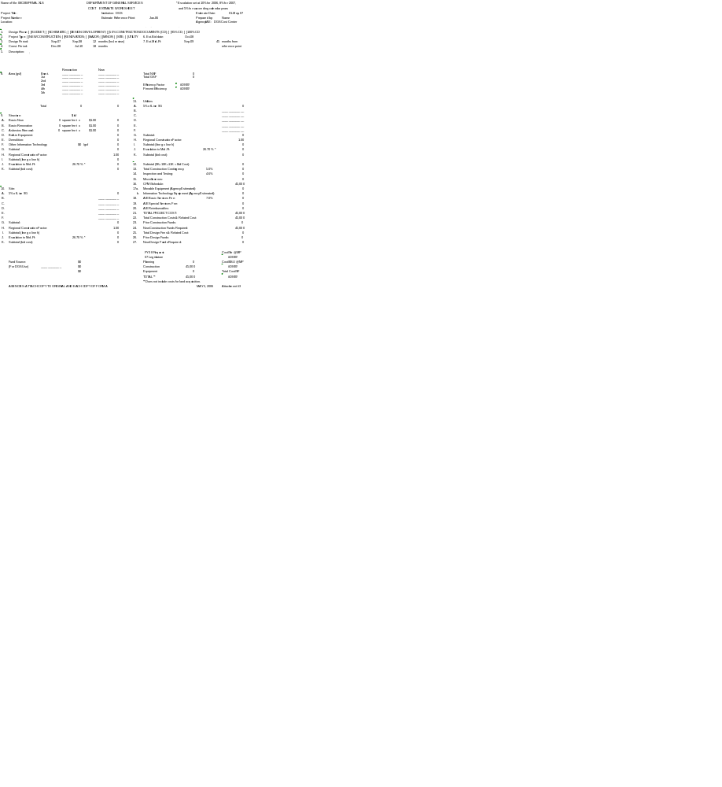

REQUEST FOR DETERMINATION OF PREVAILING WAGE RATES

TO: Commissioner of Labor & Industry

FROM: (Contracting Body) Architect:

* * * * * * * * * * * * * *

Date of Request:

Name of Project:

Project Number:

Location of Project: (City) (County)

Estimated Advertising Date:

Estimated $ Value of Contract:

Description of Work: (Specify)

Check or List Crafts Needed:

Asbestos/Insul Worker Lather Power Equip. Oper.
Boilermaker Painter
Bricklayer Piledriver
Carpenter Plasterer
Cement Mason Plumber
Electrician Roofer
Elevator Constructor Sheet Metal Worker Other Crafts:
Glazier Resilient Floor Layer Communication Tech
Ironworker: Sprinklerfitter
Reinforcing Steamfitter/Pipefitter
Structural Tile & Terrazzo Mechanic
Laborer: Tile & Terrazzo Finisher
Truck Driver
Welder (Rate for Craft)

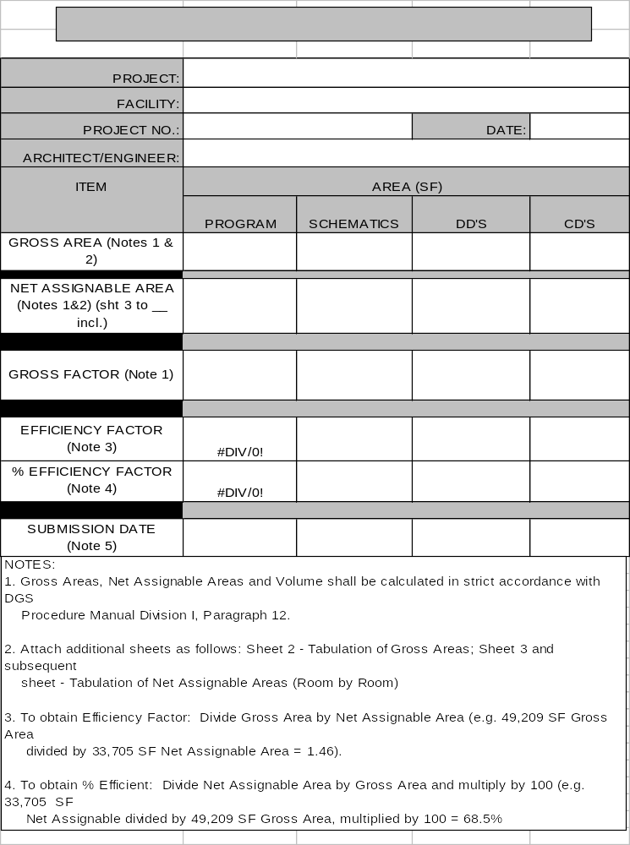

14.03 MARYLAND HIGHER EDUCATION COMMISSION FORMS/INSTRUCTIONS

- State Share Percentages: FY 2000 – FY 2009 Community College Capital Projects

- Annual Budget & Five-Year Capital Improvement Program (CIP)
Instructions and Forms
  - CBIS Part IIIA Report: Project Detail (DBM Form, see 14.01)
  - CBIS Cost Estimate Worksheet (DBM Form, see 14.01)
  - CB Form B: Summary of Agency Project Requests (DBM Form, see 14.01)
  - CB Form G: Equipment and Furnishings Request (DBM Form, see 14.01)
  - Project Impact Statement
  - CC Form M: Letter of Intent.
  - CC Form N: Resolution.
  - CC Form O: Petition.

- CC Form P: Quarterly Cash Flow Projection
  - Instructions & Example

- CC Tables 1-4: Space Allocation Guidelines
  - Instructions
  - CC Table 1: Space Inventory by Building

CC Table 2: Total Existing Space Inventory – Net Assignable Square Feet
  - CC Table 3: Computed Needs in Net Assignable Square Feet
  - CC Table 4: Computation of Parking Allowance

- Facilities Inventory System: Notes and Example Form

- Allocation Request Letters - Sample Templates
  - Design with Basic and Special Services
  - Construction
  - Construction with Contingency & CITS
  - Construction with Alternates
  - Furnishing & Equipping: Multiple Vendors
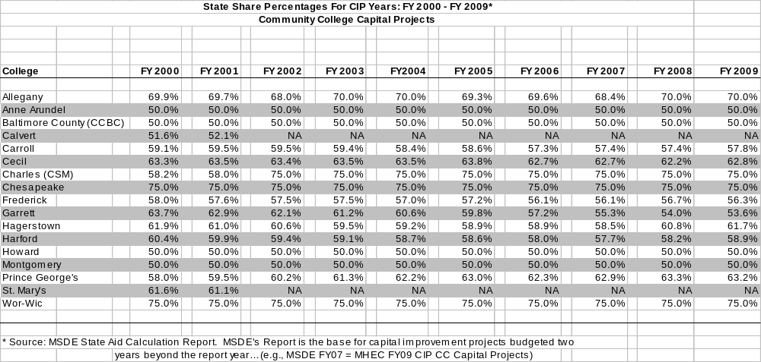
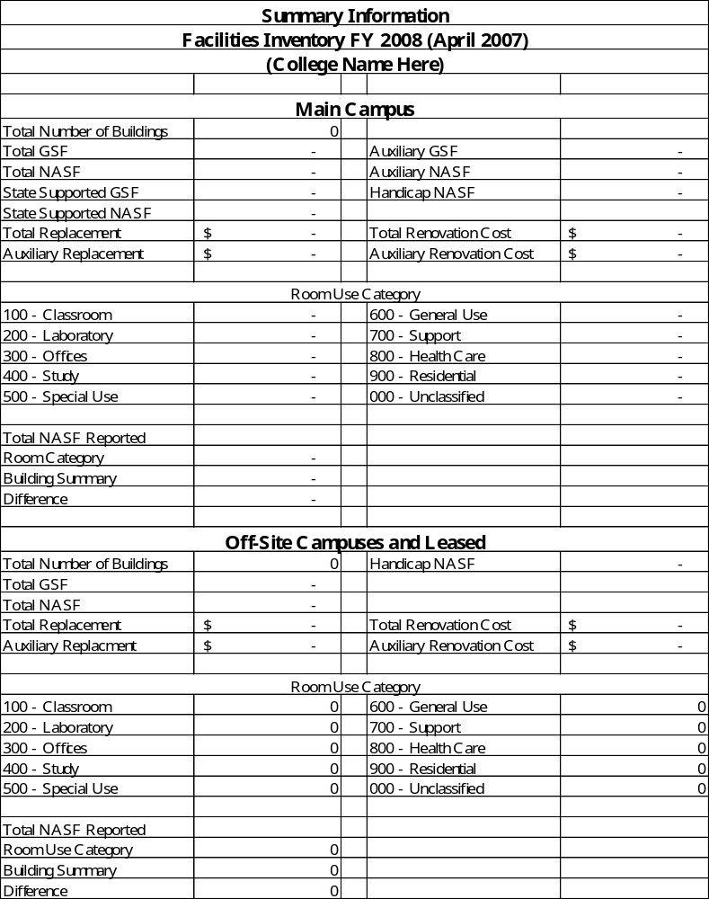Source: Facilities Inventory System, MHEC, 12/1996 w:\capital\facinven\instruct\spacetmp.xls

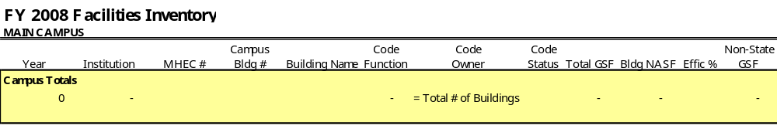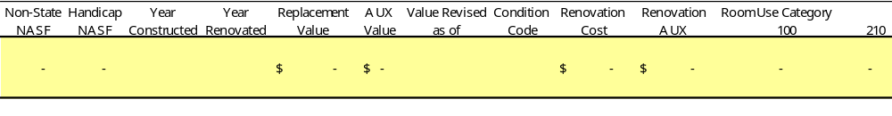
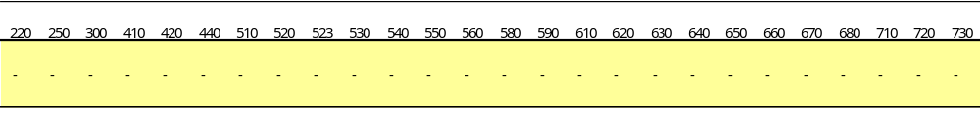
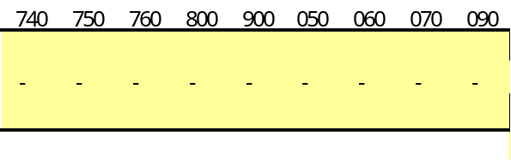
Source: Facilities Inventory System, MHEC, 12/1996 w:\Capital\Facilities\CC\Facilities Inventory FY05 Template 3-18-04.xls

Note. Read the headers left to right, top to bottom.

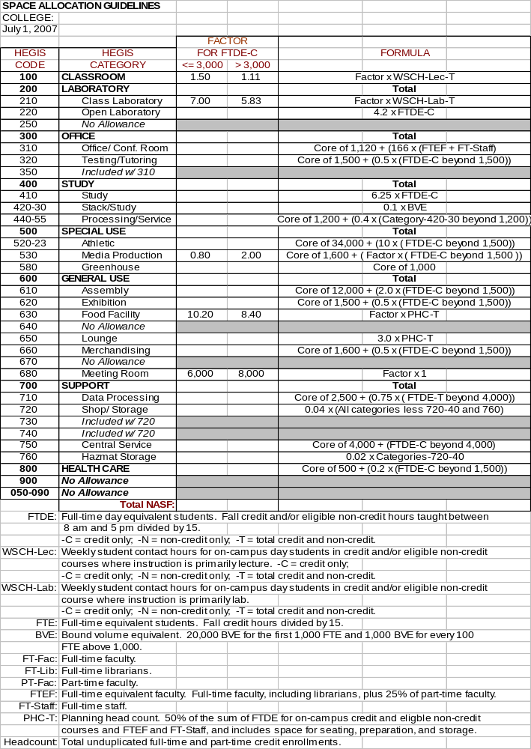
FIVE-YEAR CAPITAL IMPROVEMENT PROGRAM
INSTRUCTIONS FOR COMPLETING FORMS

The following instructions are provided to assist college personnel in completing the forms for submission of the five-year capital improvements program (CIP), the annual budget request, and individual project proposal submissions.

June 1 is the deadline for submission of the annual capital budget request and 5-year CIP to MHEC. The request should include those projects proposed for the upcoming budget year and those planned for the following four fiscal years. Four (4) complete copies of the CIP are required: one for the Maryland Higher Education Commission (MHEC); one for the Department of Budget and Management (DBM); one for the Department of General Services (DGS); and one for the Maryland Association of Community Colleges (MACC). All copies should be forwarded to MHEC for distribution. The Maryland Community College Facilities Planners Council, Bond Bill Review Committee, receives preliminary copies of the Project Impact Statement, Form B, and Questionnaire/Checklist to complete its initial review prior to the June 1 budget request deadline.

Colleges are requested to bring forth only those projects that are in an approved master plan, are supported by the local subdivision for the next fiscal year, and have a reasonable expectation of starting during that time period. Project schedules should be scrutinized to assure that requested funds are required in the upcoming fiscal year. Capital authorizations are enacted in April, following the 90-day session of the Maryland General Assembly, and these funds become available on June 1.

In completing the CIP process, facilities officers and institutional research officers should direct special attention to the following:

- Refer to the State Share Percentage for the budgeted fiscal year to determine the funding level for new projects,

- Program submittals must follow the current edition: “Facility Program Manual, Department of General Services and Department of Budget and Management."

SUBMISSION REQUIREMENTS FOR THE ANNUAL CAPITAL BUDGET REQUEST/CIP
(with reference to Facilities Manual sections that provide examples)

Due June 1: Annual Capital Budget Request and CIP

- CBIS Part III A Report: Project Detail (Section 14.01).

- CBIS Cost Estimate Worksheet (CEW) (Section 14.01).

- CB Form B (MS Excel): Summary of Five-Year Capital Improvement Program (Section 14.01)

This form summarizes all projects requested in the annual budget request and those proposed for the four subsequent fiscal years. Projects must be listed in priority, starting with the current budget year.

- CB Form G (MS Excel): Equipment and Furnishings Request (Section 14.01)

- Impact Statement (MS Excel): Project Justification & Summary (Section 14.03, example below)

The Impact Statement must accompany each project request submitted for the budget year. The narrative must address project scope, including justification, and must provide a summary of the project’s impact on space and enrollment capacities. Data tables are included to reflect the project’s impact on NASF, classroom/laboratory capacities, and enrollments.

- CC Form M: Letter of Intent (Section 14.03, example below)

The Letter of Intent is to be completed for each project which will be included in the next annual budget request and must be submitted with the Annual Capital Budget Request. In lieu of the Letter of Intent, an institution may submit a copy of the county’s Capital Improvement Program if the project is included in that document and if the document has been approved by the county’s legislative body.

- CC Form N: Resolution (Section 14.03, example below)

The Resolution is a formal request to the county by the Board of Trustees (BOT) of the college to: approve the proposed plans for acquisition, design or construction of a project; file a petition with MHEC for a State grant in a specified dollar amount; and, make available the necessary local funds for completion of the project. The Resolution is under the signature of the Secretary-Treasurer of the Board of Trustees of the college and must be submitted to MHEC along with the county’s Petition (CC Form O.)

- CC Form O: Petition (Section 14.03, example below)

At the request of the BOT of the college, the county files a Petition with MHEC for a grant of State funds to be released from the available community college construction loan program. The Petition is under the signature(s) of the County Council Executive and Commissioners/Council Members and includes a statement confirming the county’s commitment to provide all the remaining funds necessary to complete the project.

Due July 1: CC Tables 1-4 (MS Excel Workbook example, below)

The CC Tables 1-4 Workbook is distributed electronically to each community college in May with a turnaround due date of July 1. Embedded formulas use data from CC Table 1 (existing facilities inventory), CC Table 2 (projected facilities inventory ), CC Table 3 (enrollment and space projections), and CC Table 4 (parking space calculations) to automatically calculate current and 10-year projected inventories for facilities and parking needs.

CC Table 1: Space Inventory By Building – Existing Inventory

This worksheet is used to record existing on-campus buildings space inventory, including on-campus permanent and on-campus overflow, i.e., temporary buildings. List all facilities, including those built without State funds

Definitions: On-Campus. All sites where instructional and administrative programs are offered (main campus and off-site locations).

On-Campus Permanent Space. Space directly related to market driven conditions (choice of location, not force of location). Includes owned and leased space on the main campus and all off-site locations, provided the space is permanent and dedicated to the college.

On-Campus Overflow Space. Space directly related to overflow conditions (when the college is unable to accommodate on-campus demand). Shared space, such as in K-12 or community facilities, is generally considered overflow.

CC Table 2: Total Existing Space Inventory to 10-Year Projected

In this worksheet, Column 1 lists current inventory, by HEGIS code, as recorded in Table 1,excluding temporary buildings or buildings not intended to be in use for 15 years. Include in the inventory, under the appropriate out-year, approved projects under design or construction and any proposed changes requested in the planned capital improvements program. An explanation of the projected space additions or deletions must be attached.

CC Table 3: Computed Needs in Net Assignable Square Feet

This worksheet calculates and indicates current and 10-year projected space requirements as compared to projected inventories. Space requirements are based on projected enrollments endorsed by the Maryland Higher Education Commission’s June 1 publication: Enrollment Projections.

CC Table 4: Computation of Parking Allowance

This worksheet reflects the current and 10-year projected parking space eligible for State financial participation.

Due Each Quarter: Form P – Quarterly Cash Flow Report

CC Form P (MS Excel): Quarterly Cash Flow Projection Report (Section 14.03, example below)

The CC Form P (revised 3/2002) includes four (4) worksheets: Cash Flow Reporting Instructions; Cash Flow Projections; Project Design Status of New Construction; and, Project Status of New Construction. This report is submitted to MHEC after each fiscal quarter to indicate actual and projected cash flows related to active capital projects. The projections are used to analyze project activities and to forecast expenditures and general bond requirements. These projections form the basis of the Commission’s request for the issuance of bonds to support payment of the State’s share of community college capital projects. Due dates are the third Friday of each month, following the end of each quarter: January, April, July and October.

FORMS ON THE FOLLOWING PAGES ARE FOR EXAMPLE ONLY

UPDATED, ACTIVE FORMS MAY BE ACQUIRED BY CONTACTING MHEC AT

410-260-4550.
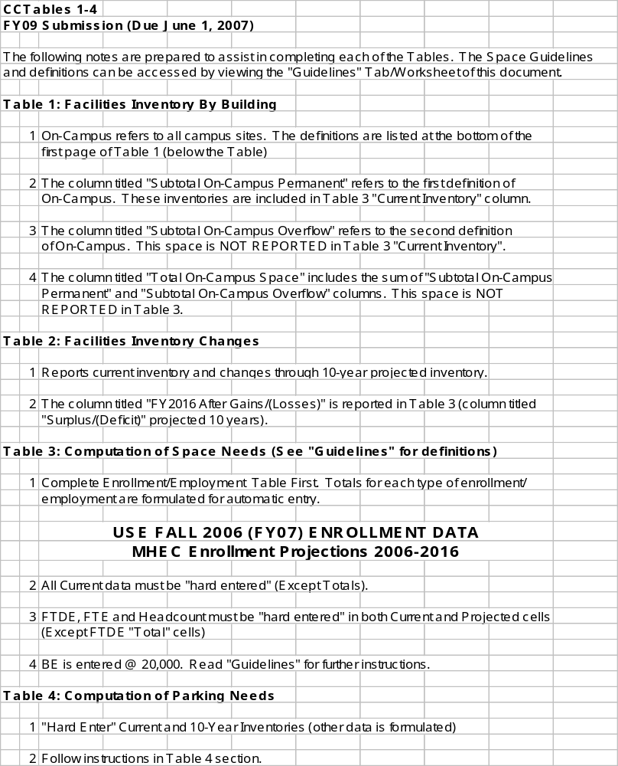
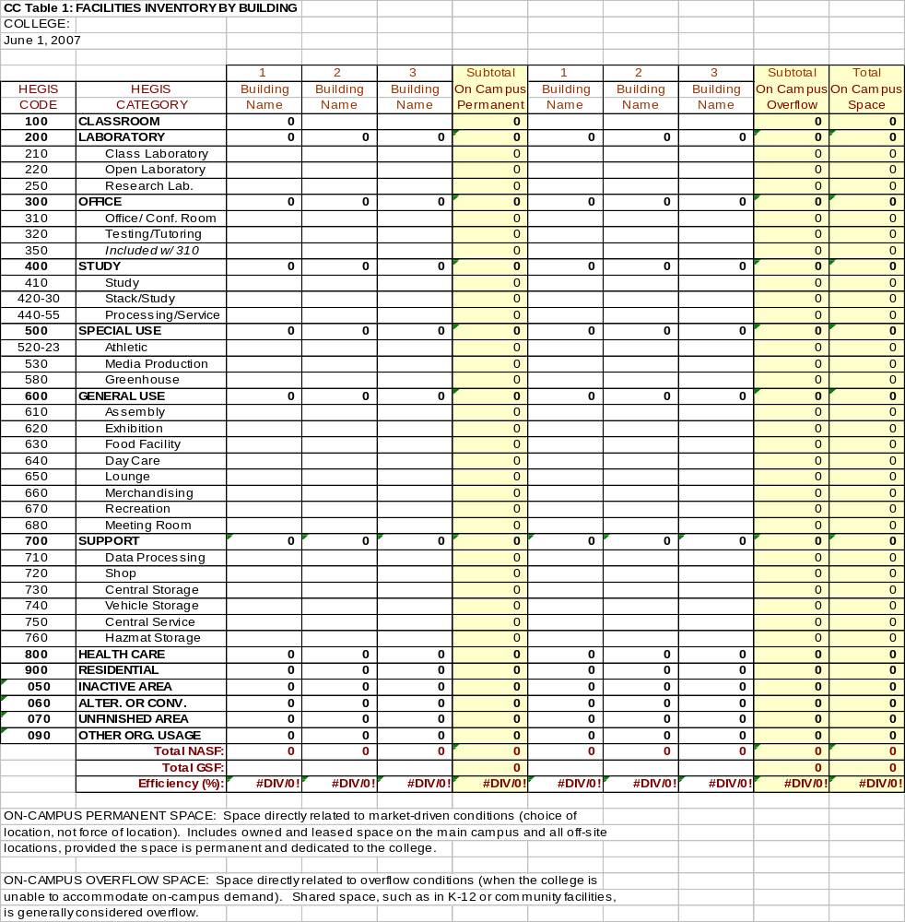
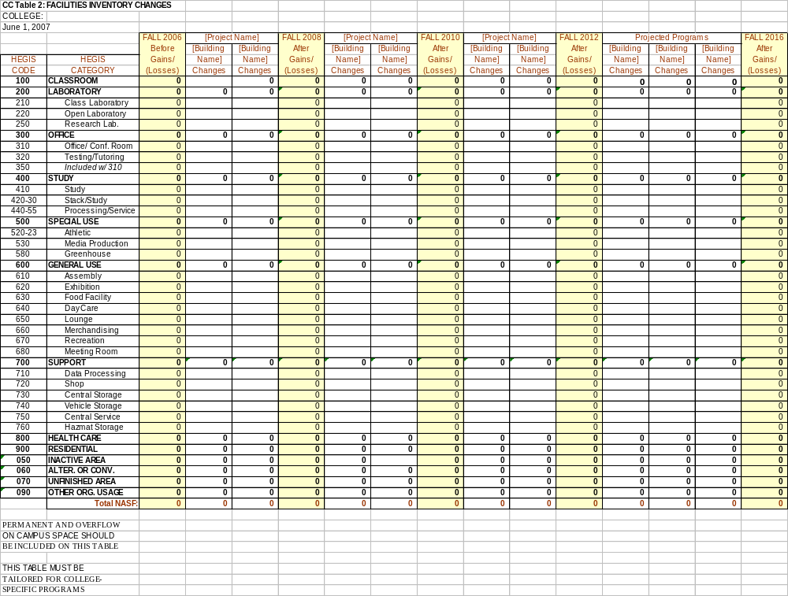
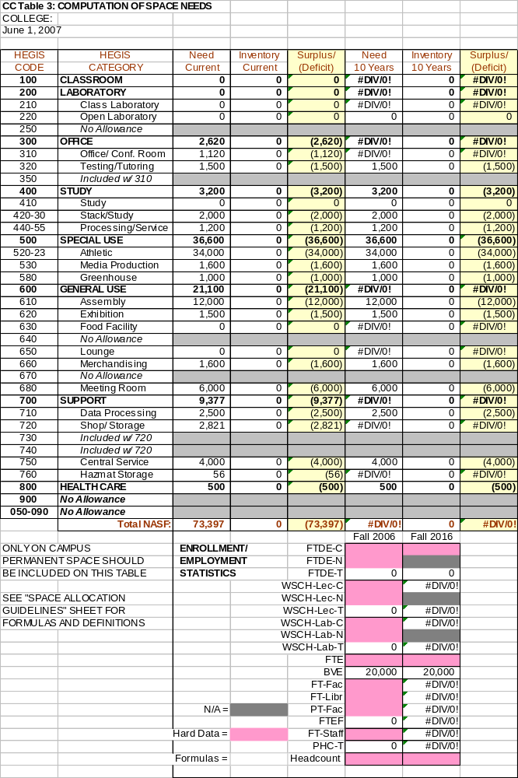
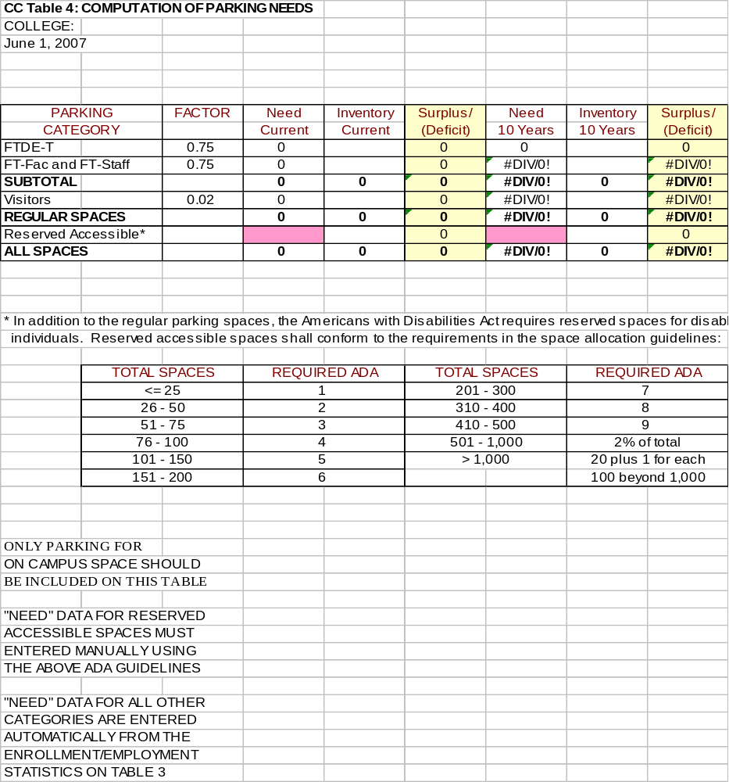
Project Impact Statement

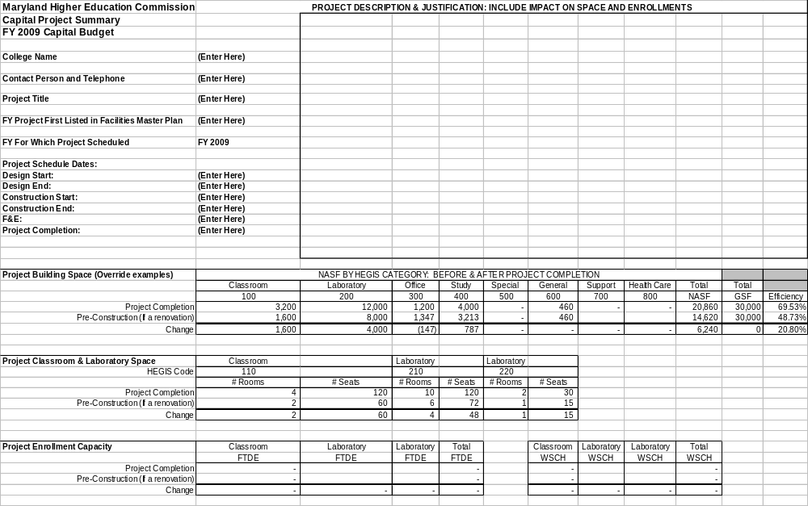- CC FORM M -

LETTER OF INTENT

MARYLAND COMMUNITY COLLEGES

TO: Maryland Higher Education Commission
839 Bestgate Road Suite 400
Annapolis, MD 21401-3013

RE: __________________________

__________________________
(Project Title)

This Letter of Intent is to assure the Maryland Higher Education Commission that the county intends to provide the local share of funds to design, construct, and equip the above referenced project.

A Resolution and Petition for the State's share of funds to design this facility will be submitted with the Annual Capital Budget Request, on or before ______ (approximate date of submission).

Signatures of:

(County Council)

(County Commissioners)

(County Executive)

Date: _________________

- CC FORM N -

RESOLUTION
MARYLAND COMMUNITY COLLEGES

RE: Proposal to Construct a Public Junior, Community,
or Regional Community College or Addition Thereto

Board of Trustees of ___________ County Community College
_____________, Maryland

WHEREAS, The General Assembly of Maryland has enacted various community college construction loan acts that provide State funds to assist the counties in the financing of the cost of the acquisition of land and in the construction of public junior, community, or regional community college buildings and facilities, the cost of which were incurred after the effective dates of the acts; and

WHEREAS, The Board of Trustees of __________ County Community College proposes the (acquisition of land) (design) (construction of a public community) (construction of additional buildings and/or facilities of the public community college) at or near , Maryland and has determined that the sum of dollars ($ ) in State financial assistance available under said acts is needed for this purpose;

NOW, THEREFORE, BE IT RESOLVED, That the Board of Trustees of ___________ County Community College does hereby formally request the County Commissioners to approve the proposed plans for (acquisition) (design) (construction) as set forth in the application for financial assistance, to file, as required by the provisions of acts, the necessary petition with the Maryland Higher Education Commission for a State grant in the amount of dollars ($ ) and to make available the necessary local funds for completion of the project.

A True Copy
ATTEST:
Secretary-Treasurer
Board of Trustees of _______ County Community College
Date Project:
- CC FORM O -

PETITION
MARYLAND COMMUNITY COLLEGES

RE: Petition for Grant of $ _________________
Board of Trustees of ____________ County Community College
________________, Maryland

WHEREAS, The General Assembly of Maryland has enacted various community college construction loan acts that provide State funds to assist the counties in the financing of the cost of the acquisition of land and in the construction of public junior, community, or regional community college buildings and facilities, the cost of which were incurred after the effective dates of the acts; and

WHEREAS, A petition to participate in the financial assistance provided in the acts must be filed by the County Commissioners with the Maryland Higher Education Commission; and

WHEREAS, The Board of Trustees of __________ County Community College proposes the (acquisition of land) (design) (construction of a public community college) (construction of additional buildings and/or facilities of the public community college) at or near County, Maryland; and upon resolution duly adopted by it, a copy of said Resolution being appended hereto, request the County Commissioners of County, Maryland to petition the Maryland Higher Education Commission for the sum of dollars ($) needed for the purpose of assisting the financing of the public community project which is described in the application for financial assistance;

NOW, THEREFORE, BE IT RESOLVED, By the County Commissioners of ___________County, Maryland that petition is hereby made to the Maryland Higher Education Commission for a grant of ____________________________dollars ($______________) from the available funds of the various community college construction loan acts in order to participate in said financial assistance; and

BE IT FURTHER RESOLVED, That the County Commissioners of ___________County, Maryland shall provide all the remaining funds necessary to complete the described project even if the Board of Public Works approves a grant which is less than the amount requested by this Petition.

Signatures of County Commissioners: ____________________________________
____________________________________
____________________________________
____________________________________
____________________________________

Date: Project: ____________________________
- CC FORM P -

QUARTERLY CASH FLOW REPORT: EXAMPLE

M E M O R A N D U M

TO: Facilities Planners
Maryland Community Colleges

FROM: David S. Beard
Finance Policy Analyst

SUBJECT: Quarterly Cash Flow Report - Status of Funded Projects at Maryland Community Colleges

Attached is the FY 2004 FORM P, Third Quarter template. The template contains four worksheets: 1-Instructions; 2-Cash Flow Projections; 3-Status of Design; and 4-Status of New Construction. Please USE THE ATTACHED WORKSHEET to fill in the necessary information and return to MHEC by Friday, April 23, 2004.

When completing the requested information, please note the following:

•The dates for each quarter in this report are as follows:

First Quarter - July 1-September 30, 2004 - PROJECTED
Second Quarter - October 1-December 31, 2004 - PROJECTED
Third Quarter - January 1-March 31, 2004 - ACTUAL
Fourth Quarter - April 1-June 30, 2004 – PROJECTED

• Only the State Share in the Cash Flow sheet is to be reported. This information is used to project cash disbursements by general obligation bond bills and to report expenditures to the Maryland State Treasurer. The Design and Construction sheets require State Costs and Total Costs for each project. In addition, please include your College Name in Row 5, Cash Flow sheet. Without this information, identifying the college is difficult. Please submit the information in a timely manner. Thank you for your cooperation and please call me at (410) 260-4550 if you have any questions.

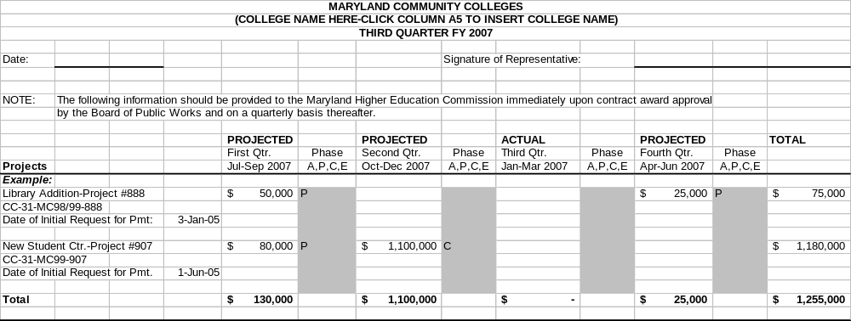
DOUBLE-CLICK INSIDE TABLE TO ACCESS SAMPLE TEMPLATE AND WORKSHEET TABS
ALLOCATION REQUEST

DESIGN WITH BASIC AND SPECIAL SERVICES

*****

Date

Mr. David S. Beard
Finance Policy Analyst
Maryland Higher Education Commission (MHEC)
839 Bestgate Road Suite 400
Annapolis, MD 21401-3013

Re. ABC College – Wye River Campus
Academic Building 1 - Design

CC-99-MC02-999

Dear Mr. Beard:

ABC College requests that the Maryland Higher Education Commission recommend State participation in funding for design of the Academic Building 1 project in the amount of $100,000 (State Share of 50.0%) and forward that recommendation to the Department of General Services (DGS) for presentation to the Board of Public Works (BPW) for approval. The College recommends award of the contract to the low responsive bidder, XYZ Design, with a total design fee of $200,000, which includes basic services of $175,000 and special services for: “a” service - $10,000; “b” service - $10,000; and “c” service - $5,000.

Attached are copies of the Board of Trustees Resolution and award recommendation, the County's Petition for State assistance and all required design items as listed on the DGS/BPW checklist. Copies of this package have been forwarded to the Department of Budget and Management and the Department of General Services as appropriate.

This phase is scheduled to begin Date and to be completed by Date.

If you have any questions, please call me at (123) 456-7890.

Sincerely,

John Doe

cc: Marissa Kuhn, DBM
Robert Machin, DGS
ALLOCATION REQUEST

CONSTRUCTION

*****

Date

Mr. David S. Beard
Finance Policy Analyst
Maryland Higher Education Commission (MHEC)
839 Bestgate Road Suite 400
Annapolis, MD 21401-3013

Re. ABC College – Wye River Campus
Academic Building 1: Construction

CC-99-MC02-999

Dear Mr. Beard:

ABC College requests that the Maryland Higher Education Commission recommend State participation in funding for construction of the Academic Building 1 in the amount of $438,400 (State Share of 50.0%) and forward that recommendation to the Department of General Services (DGS) for presentation to the Board of Public Works (BPW) for approval. The College recommends award of the contract to the low responsive bidder, Contractor, Inc., with a total construction fee of $876,800.

Attached are copies of the Board of Trustees Resolution and award recommendation, the County's Petition for State assistance and all required construction items as listed on the DGS/BPW check list. Copies of this package have been forwarded to the Department of Budget and Management and the Department of General Services as appropriate.

Construction is scheduled to begin Date and to be completed by Date.

If you have any questions, please call me at (123) 456-7890.

Sincerely,

John Doe

cc: Marissa Kuhn, DBM
Robert Machin, DGS
ALLOCATION REQUEST

CONSTRUCTION WITH CONTINGENCY & CITS

*****

Date

Mr. David S. Beard
Finance Policy Analyst
Maryland Higher Education Commission (MHEC)
839 Bestgate Road Suite 400
Annapolis, MD 21401-3013

Re. ABC College – Wye River Campus
Academic Building 1: Construction

CC-99-MC02-999

Dear Mr. Beard:

ABC College requests that the Maryland Higher Education Commission recommend State participation in funding for construction of the Academic Building 1 in the amount of $438,400 (State Share of 50.0%) and forward that recommendation to the Department of General Services (DGS) for presentation to the Board of Public Works (BPW) for approval. The College recommends award of the contract to the low responsive bidder, Contractor, Inc., with a total construction fee of $876,800, which includes a base of $800,000 plus a 5% contingency allowance of $40,000 and a 4.6% construction inspection and testing services fee of $36,800.

Attached are copies of the Board of Trustees Resolution and award recommendation, the County's Petition for State assistance and all required construction items as listed on the DGS/BPW check list. Copies of this package have been forwarded to the Department of Budget and Management and the Department of General Services as appropriate.

Construction is scheduled to begin Date and to be completed by Date.

If you have any questions, please call me at (123) 456-7890.

Sincerely,

John Doe

cc: Marissa Kuhn, DBM
Robert Machin, DGS
ALLOCATION REQUEST

CONSTRUCTION WITH ALTERNATES

*****

Date

Mr. David S. Beard
Finance Policy Analyst
Maryland Higher Education Commission (MHEC)
839 Bestgate Road Suite 400
Annapolis, MD 21401-3013

Re. ABC College – Wye River Campus
Academic Building 1: Construction

CC-99-MC02-999

Dear Mr. Beard:

ABC College requests that the Maryland Higher Education Commission recommend State participation in funding for construction of the Academic Building 1 in the amount of $438,400 (State Share of 50.0%) and forward that recommendation to the Department of General Services (DGS) for presentation to the Board of Public Works (BPW) for approval. The College recommends award to the low responsive bidder, Contractor, Inc., with a base bid of $800,000 plus alternates1-a for $40,000 and 1-b for $36,800 for a total award of $876,800.

Attached are copies of the Board of Trustees Resolution and award recommendation, the County's Petition for State assistance and all required construction items as listed on the DGS/BPW check list. Copies of this package have been forwarded to the Department of Budget and Management and the Department of General Services as appropriate.

Construction is scheduled to begin Date and to be completed by Date.

If you have any questions, please call me at (123) 456-7890.

Sincerely,

John Doe

cc: Marissa Kuhn, DBM
Robert Machin, DGS
ALLOCATION REQUEST

FURNISHING & EQUIPPING: MULTIPLE VENDORS

*****

Date

Mr. David S. Beard
Finance Policy Analyst
Maryland Higher Education Commission (MHEC)
839 Bestgate Road Suite 400
Annapolis, MD 21401-3013

Re. ABC College – Wye River Campus
Academic Building 1: Furnishing & Equipping

CC-99-MC02-999

Dear Mr. Beard:

ABC College requests that the Maryland Higher Education Commission recommend State participation in funding for furnishing and equipping the Academic Building 1 in the amount of $150,000 (State Share of 50.0%) and forward that recommendation to the Department of General Services (DGS) for presentation to the Board of Public Works (BPW) for approval. The College recommends award to the low responsive bidders, Furnishings, Inc. for $200,000 and Equipping-U, Inc. for $100,000 for a total award of $300,000.

Attached are copies of the Board of Trustees Resolution and award recommendation, the County's Petition for State assistance and all eligible furnishing/equipping items as listed on the DGS/BPW check list. Copies of this package have been forwarded to the Department of Budget and Management and the Department of General Services as appropriate.

This last phase of the project is scheduled to begin Date and to be completed by Date.

If you have any questions, please call me at (123) 456-7890.

Sincerely,

John Doe

cc: Marissa Kuhn, DBM
Robert Machin, DGS
14.04 Facility Program Manual, CURRENT Edition

See the Department of Budget and Management’s web site for the current edition of the Facility Program Manual:
http://dbm.maryland.gov/dbm_publishing/public_content/dbm_taxonomy/budget/capital_budget/capital_budget_instructions/facilityprogmanual.pdf
14.05 Procedure Manual for Professional Services, Current Edition

See the Department of General Services’ web site for the current edition of the Procedure Manual for Professional Services:

http://www.dgs.maryland.gov/overview/const2.htm
14.06 Instructions for the Preparation and Submission of Capital Project Requests for NON-State Projects within A state GRANT AND Loan Programs, Current EDITION

See the Department of Budget and Management’s web site for the current edition of instructions:

http://dbm.maryland.gov/dbm_publishing/public_content/dbm_taxonomy/budget/capital_budget/capital_budget_instructions/capitalbudgetinstructions.html

14.07 ROOFING POLICY

