**The Universities at La Plata**

**8730 Mitchell Road**

**LR Building, Suite 101**

**La Plata, MD**

**Advising Hours of Operation: Monday-Friday 8:30 am to 5:00 pm**

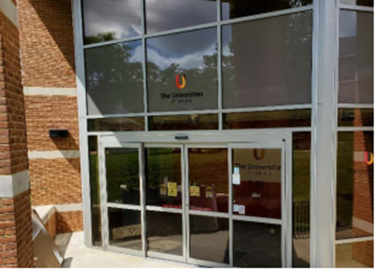**Background:**

* The Universities at La Plata is a state-approved regional education center approved by the Maryland Higher Education Commission to foster degree completion amongst the students of the Southern Maryland community.
* The Universities at La Plata is a partnership between University of Maryland Global Campus and College of Southern Maryland to offer educational opportunities to students in areas and communities without traditional higher educational options.
* It was opened in 1999 as the Waldorf Center for Higher Education and in July 2020 the center was moved to the College of Southern Maryland La Plata campus and renamed to the Universities at La Plata. As a result of the relocation, we have had no change in capacity to meet students’ educational needs in the Southern Maryland community.
* Following the COVID-19 Pandemic, we reopened our on-site services in March 2022 and began re-offering hybrid classes with on-site classroom learning for the Summer 2022 semester.
* UMGC administrates the operation of The Universities at La Plata, working and operating in proximity and partnership with the College of Southern Maryland staff. We rent office space and classroom space from our intuitional partners at the College of Southern Maryland La Plata.

**Staffing and Services:**

* Our center staff consists of one team associate (administrative tasks), three success coaches (advising and student support), and one director of the center. All staff are employed by UMGC.
* Students also have the added benefit of using UMGC full and extensive network of support services, including: Admissions Services, Degree Planning and Academic Advising, Financial Aid, Scholarships, Tuition Planning and Payment Options; Lifetime Career Service Support, Veteran Support Services, Accessibility Services, Student Organizations and Clubs, and Honor Societies.
* We offer on-site academic advising, on-site hybrid UMGC courses, and access to UMGC’s fully online catalog of courses.

**Programs and Benefits:**

* Access to 135+ programs and degrees, which include 30+ Bachelor's Degrees, 40+ Master’s Degrees, and numerous Undergraduate and Graduate certificates.
* Our accessible and flexible,evening classes are held across 3 semesters; Fall (August to December), Spring (January to May), and Summer (May to August).
* The Maryland Completion Scholarship is for students who have completed their Associate’s Degree at a Maryland community college. Recipients are guaranteed completion of the Bachelor’s Degree for $12,000 or less.
* Our Veterans Initiative Office provides access to our Vet Success On Campus counselors, One2One mentorship, Vessey Veterans Resource Center, SALUTE National Honor Society, Students of America, and scholarships such as the Pillar of Strength.

**Student Enrollments by Fiscal Year:**

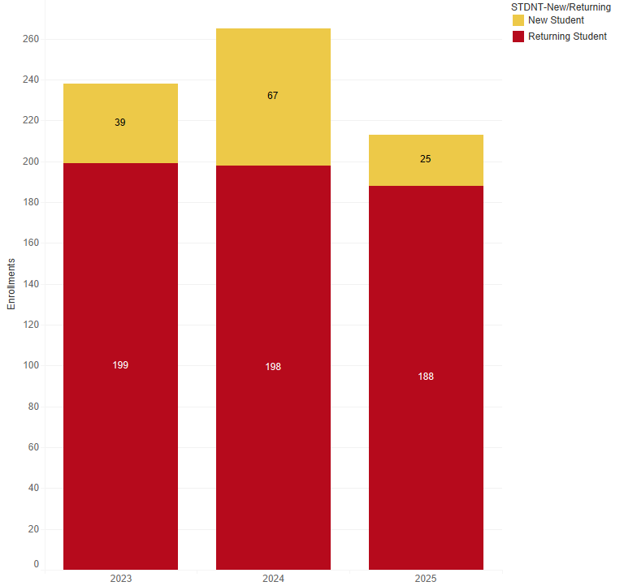

*FY 2025 enrollments are still in progress